📄 Test Case: TC59_InwardLodgeBill
✅ PASSED:
[2026-03-13 10:05:46] Bill ID - 003B0503_2025 Lodged successfully.
[2026-03-13 10:07:06] Bill ID - 003B0503_2025 verified successfully.

📄 Test Case: TC60_ModifyTheLodgeBillWhichIscreated
❌ FAILED:
[2026-03-13 10:07:57] ? Exception Occurred: Expected condition failed: waiting for visibility of element located by By.id: menuSelect (tried for 10 second(s) with 500 milliseconds interval)
Build info: version: '4.38.0', revision: '6b412e825c*'
System info: os.name: 'Windows 11', os.arch: 'amd64', os.version: '10.0', java.version: '17.0.12'
Driver info: org.openqa.selenium.edge.EdgeDriver
Capabilities {acceptInsecureCerts: false, browserName: MicrosoftEdge, browserVersion: 145.0.3800.97, fedcm:accounts: true, goog:processID: 21800, ms:edgeOptions: {debuggerAddress: localhost:52710}, msedge: {msedgedriverVersion: 145.0.3800.97 (f4c49d5241f1..., userDataDir: C:\Users\chris\AppData\Loca...}, networkConnectionEnabled: false, pageLoadStrategy: normal, platformName: windows, proxy: Proxy(), se:cdp: ws://localhost:52710/devtoo..., se:cdpVersion: 145.0.3800.97, setWindowRect: true, strictFileInteractability: false, timeouts: {implicit: 0, pageLoad: 300000, script: 30000}, unhandledPromptBehavior: dismiss and notify, webauthn:extension:credBlob: true, webauthn:extension:largeBlob: true, webauthn:extension:minPinLength: true, webauthn:extension:prf: true, webauthn:virtualAuthenticators: true}
Session ID: a38f604fc0d228f72ba6703479927ea7
↳ Reason: ❌ ❌ Exception Occurred: Expected condition failed: waiting for visibility of element located by By.id: menuSelect (tried for 10 second(s) with 500 milliseconds interval)
Build info: version: '4.38.0', revision: '6b412e825c*'
System info: os.name: 'Windows 11', os.arch: 'amd64', os.version: '10.0', java.version: '17.0.12'
Driver info: org.openqa.selenium.edge.EdgeDriver
Capabilities {acceptInsecureCerts: false, browserName: MicrosoftEdge, browserVersion: 145.0.3800.97, fedcm:accounts: true, goog:processID: 21800, ms:edgeOptions: {debuggerAddress: localhost:52710}, msedge: {msedgedriverVersion: 145.0.3800.97 (f4c49d5241f1..., userDataDir: C:\Users\chris\AppData\Loca...}, networkConnectionEnabled: false, pageLoadStrategy: normal, platformName: windows, proxy: Proxy(), se:cdp: ws://localhost:52710/devtoo..., se:cdpVersion: 145.0.3800.97, setWindowRect: true, strictFileInteractability: false, timeouts: {implicit: 0, pageLoad: 300000, script: 30000}, unhandledPromptBehavior: dismiss and notify, webauthn:extension:credBlob: true, webauthn:extension:largeBlob: true, webauthn:extension:minPinLength: true, webauthn:extension:prf: true, webauthn:virtualAuthenticators: true}
Session ID: a38f604fc0d228f72ba6703479927ea7

📸 Screenshot:
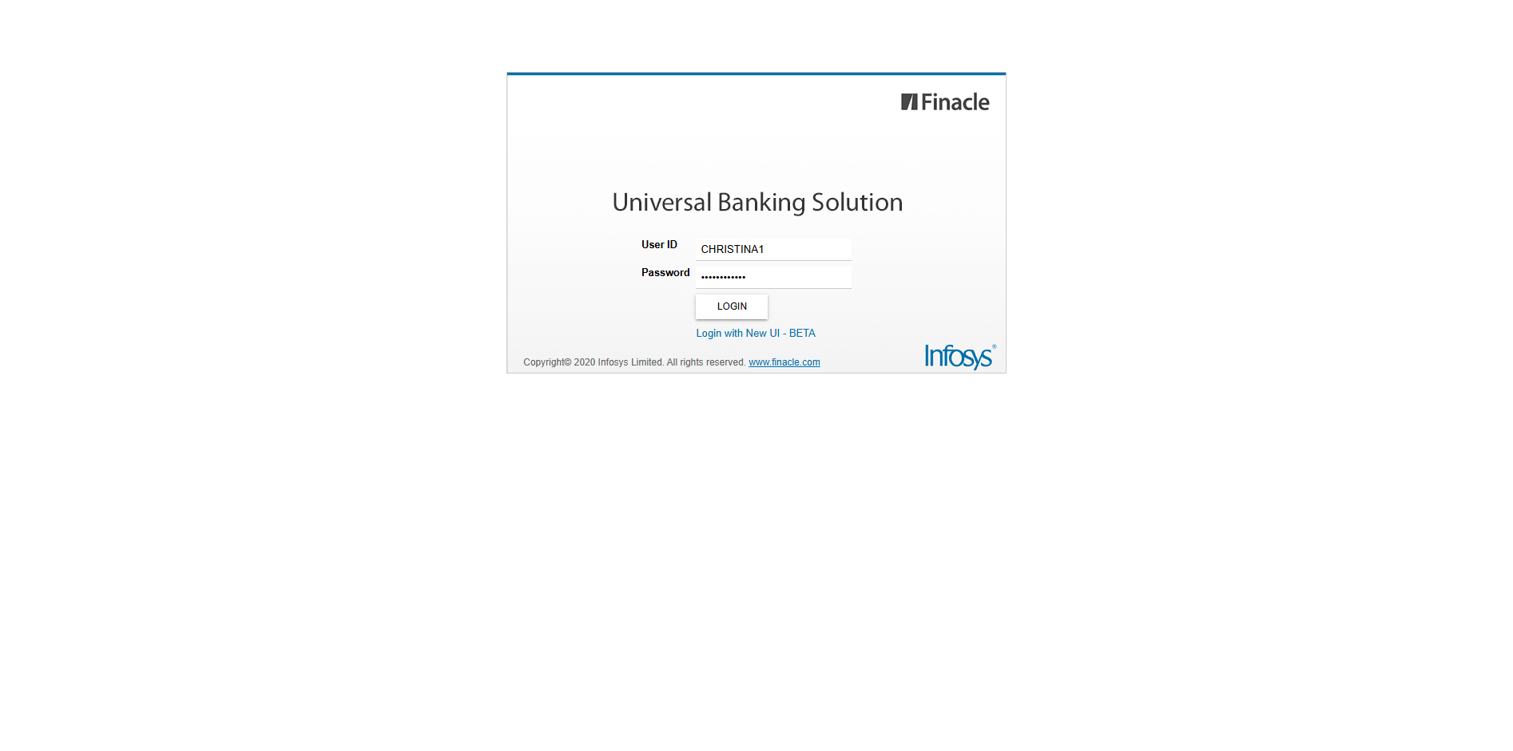
📄 Test Case: TC61_CanceltheModifiedInwardBill
✅ PASSED:
[2026-03-13 10:09:27] Bill ID - 003B0502_2025 Previous operation cancelled successfully.
[2026-03-13 10:10:18] ?? Error displayed: E4221 - [There is nothing to verify.]
[2026-03-13 10:10:18] ? Expected error E4221 received after Cancel. Test PASSED.

📄 Test Case: TC62_AmendTheInwardBillWhichIsLodge
✅ PASSED:
[2026-03-13 10:11:50] labelText = Bill ID - 003B0503_2025 Amended successfully.
[2026-03-13 10:11:50] LabelText: null
[2026-03-13 10:11:50] BillID: null
[2026-03-13 10:14:04] labelText = Bill ID - 003B0503_2025 verified successfully.
[2026-03-13 10:14:04] Verification LabelText: null
[2026-03-13 10:14:04] Verification BillID: null

📄 Test Case: TC63_DishonorOfInwardBillWhichIsAmended
✅ PASSED:
[2026-03-13 10:15:24] ? Bill ID / Label: Bill ID - 003B0503_2025 Dishonored successfully.
[2026-03-13 10:17:06] ? Verified Bill ID / Label: Bill ID - 003B0503_2025 verified successfully.

📄 Test Case: TC64_InquireTheInwardBill
✅ PASSED:
[2026-03-13 10:17:42] ? Inward Bill No: 003B0503_2025
[2026-03-13 10:17:42] ? Inquired Successfully – Import No: 003B0503_2025
[2026-03-13 10:17:42] ? AppData captured at inquiry time:
[2026-03-13 10:17:42] acceptDate_ui = 15-03-2025
[2026-03-13 10:17:42] billType = IMDCBU
[2026-03-13 10:17:42] shpmntDate_ui = 15-03-2025
[2026-03-13 10:17:42] invoiceAmt = 1000.00
[2026-03-13 10:17:42] docStatus = Clean
[2026-03-13 10:17:42] LABELTEXT_BILLID = 003B0503_2025
[2026-03-13 10:17:42] boeAmt = 1000.00
[2026-03-13 10:17:42] billCountry = 03
[2026-03-13 10:17:42] billId = 003B0503_2025
[2026-03-13 10:17:42] billDate_ui = 15-03-2025
[2026-03-13 10:17:42] carrierCode = 001
[2026-03-13 10:17:42] LabelText = Inquired Successfully – Import No: 003B0503_2025
[2026-03-13 10:17:42] otherBankRefNo = 124

📄 Test Case: TC65_ProtestTheInwardBillWhichIsDishonoured
✅ PASSED:
[2026-03-13 10:18:58] Bill ID - 003B0503_2025 Protested successfully.
[2026-03-13 10:20:43] Bill ID - 003B0503_2025 verified successfully.

============================================================
📊 Suite Summary: MIIBTests
===============================================
MIIBTests
Total tests run: 7, Passes: 6, Failures: 1, Skips: 0
===============================================
⏱️ Total Duration: 16 min 08 sec

